1. 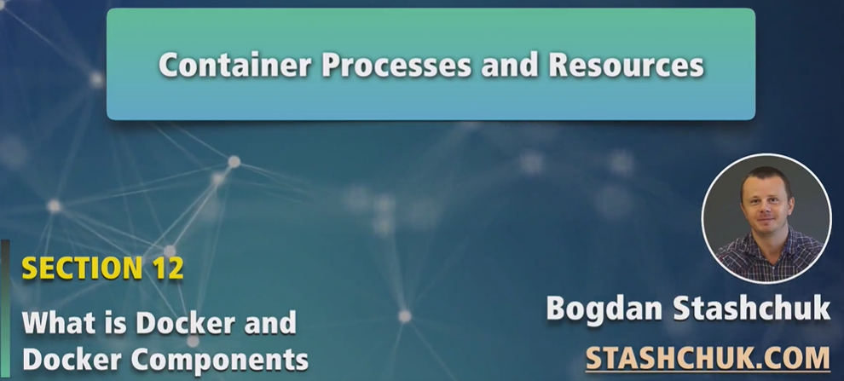
2. **NOTE**: Before starting, note **that Docker Engine needs Linux Kernel to run**.
3. Now we know that containers run on Linux host OS. If we install Docker on MAC OS or Windows, actually we install application called **Docker Desktop** and it actually creates a small Linux VM and inside that Linux VM, containers run.
4. Let’s explain how container processes interact with resources like RAM and Hard-Disk etc.
5. In the following diagram, you can see Linux host Machine. Every Linux has Linux kernel and it has resources like CPU, RAM, Network, Disk.  
   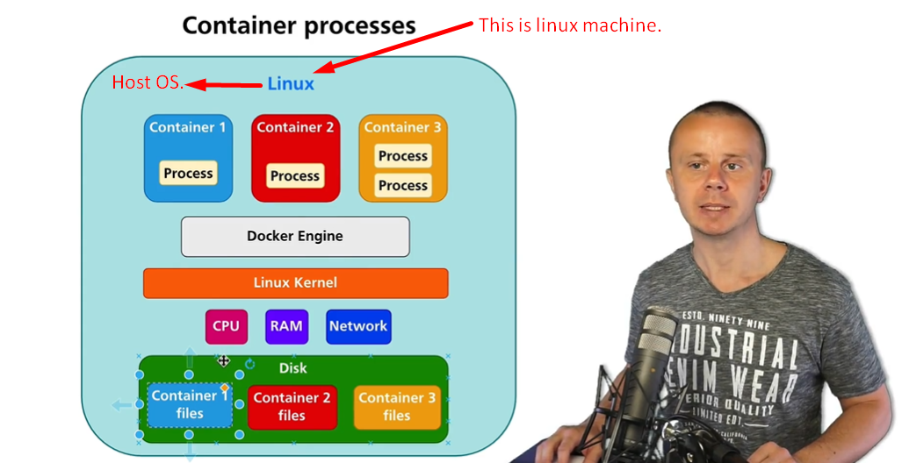
6. If we install Docker engine on Linux, it will actually install some processes that will be able to create separate resources like a separate disk space, separate processes for every container and it’s possible due to namespace. 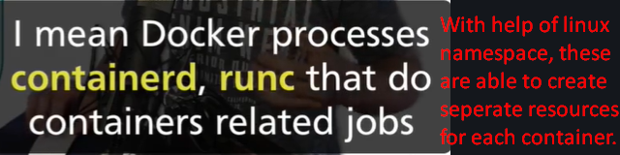
7. 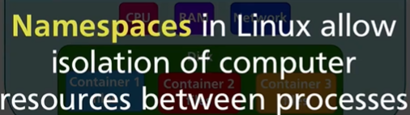
8. Namespace allows you to create separate users, separate processes, separate space on hard drive that would be completely independent of each other.
9. In the diagram, we can see separate space on hard drive for each container.
10. Before going on, let me ask you one question.
11. What is actually a computer?
12. Computer is a set of hardware like CPU, memory, hard-drive, network interface(s) and a set files. When we start computer, some files become processes that start in memory and afterwards, processes access CPU, memory, and create some files if required.  
    But in nutshell, every computer is a set of files and set of processes.   
    Same picture is with this container. When a container is started, it is a set of files on hard drive of the Linux Computer. When a container is started, some of the processes are started in the Linux machine and those processes interact via common Linux kernel.  
    **NOTE**: By default, there is no limit on resource usage. So every container can use 100% the resources allocated to Docker Engine.  
    **NOTE**: If you install Docker Engine directly on Linux Machine, it means every container can use 100% of the resources of Linux Machine.  
    **NOTE**: If you install Docker Desktop on Windows or Mac and allocate some resources to Docker Engine, Then those are the limited resources for each container.
13. 
14. In windows and MAC OS, it’s possible to limit the resources of host computer that a Docker can use as Docker Desktop has the option to configure.
15. But in Linux host machine, it is not possible but we have a utility cgroups with which we can limit the resources for the docker.
16. 